

**Basic Linux Commands Assignments**

Assignment-1

Connect and disconnect with login Access

* What happens when you login a non-existent users or username?
  + Provide Screenshot and What you understand, explain in short brief?

Answer: -

To log in to any operating system a username should be created on that system. I tried to login to system with a non-existent username and password, CentOS thrown an error stating that **“Sorry, that didn’t work. Please try again”**

Please find the below screenshot for reference.

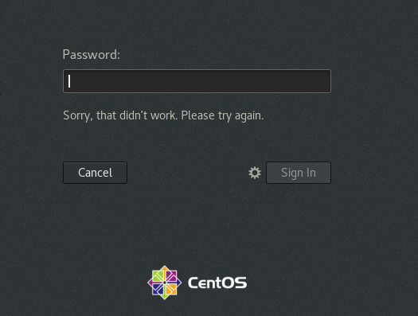

Assignment-2

Password changing

* Login into your account and then change password?
  + Change your password into **IneuR0n#42** and hit the **Enter** key
    - Explain what happen and give screenshot?

Answer: -

Tried to change password of user madhu, used command passwd in terminal, it prompted to provide the current password first. Once that is provided it prompted to enter a new password, then retype the new password. Once I hit ‘Enter’ key I got the message as **“all authentication tokens updated successfully”.** Please find the below screenshot for reference.

* + Try again to change password but use like password ***1234*** or ***abcd***
    - Explain what happen and give screenshot?

Answer: - Tried same procedure as above mentioned and able to set the new password to **1234.** And then tried to set the password to **abcd.** Then CentOS thrown an error stating that **“The password is shorter than 8 characters”** Please find the below screenshot for reference.

* + Try again to change password but now don’t use any password just hit **Enter** key
    - Explain what happen and give screenshot?

Answer: -

Tried setting up a blank password. CentOS thrown an error stating that **“BAD PASSWORD: No password supplied”** So, there should be a password set up for each user with minimum 8 characters. Please find the below screenshot for reference.

Assignment-3

Working with Directories

* Enter the command **cd /** and then **ls** and then hit **Enter** key
  + Take screenshot and explain what output we got?

Answer: -

cd / command changes our current directory to root directory of the user. Root directory is just like C drive in Windows.

Ls command will list all the files and directories available within the directory that we are in now. IN this scenario it is / directory. Please find the below screenshot for reference.

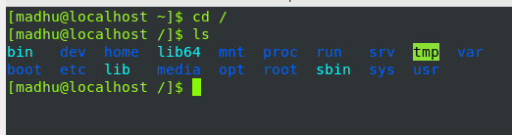

* Enter the command now **cd /home** and then hit **Enter** key
  + Do **ls,** provide screenshot and explain what is **/home** directory used for?

Answer: -

Tried checking the files in home directory. It is the user’s home directory.

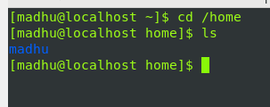

* Enter **cd ..** and hit **Enter** key [ *Note: here we have space after cd then use double dot*]
  + Check what happen and give screenshot?

Answer: -

Cd .. is the command used to come back to the previous directory. When we are in home directory and tried cd .. command, we came back to the / directory.

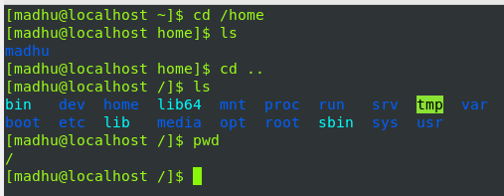

* Now enter **cd /var/www/html** and then type **cd** and hit **Enter** key
  + Explain what happen and give screenshot?

Answer: -

Tried above command and it seems there is no such directory found. When tried cd and enter it brings back to me to root directory.

* Now type **cd /root** and then hit **Enter** key
  + Do **ls,** check any output we have on screen if yes then take screenshot?

Answer: cd /root brings us to root directory and ls shows the files inside the directory.

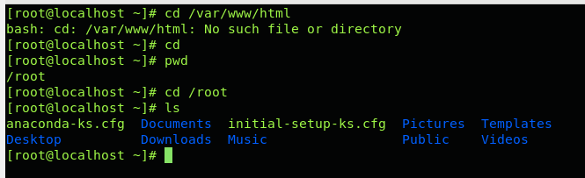

Assignment-4

Working with File Listing

* Go to **cd /etc** and type **ls**
  + Take screenshot and explain what files you have seeing?
  + Take screenshot and explain what different output you found compare to previous command you used?

Answer: - cd /etc will bring us to /etc directory. This directory has many files and some of them are configuration files.

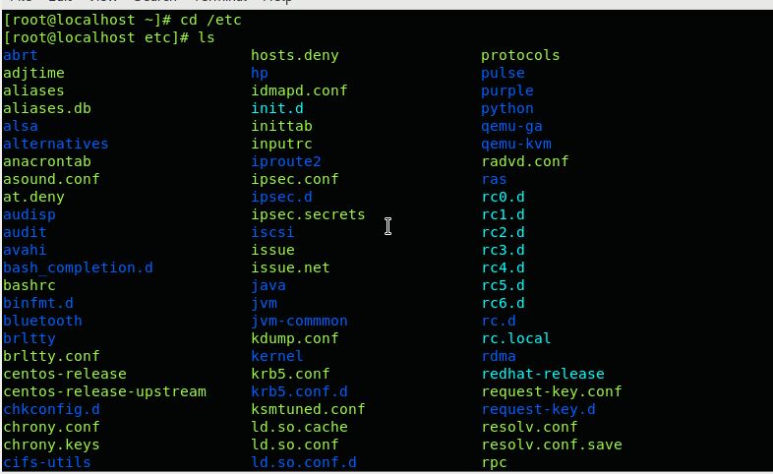

* Then type **ls -al** and hit **Enter** key
  + Take screenshot and explain what new file or directory you found?

Answer: -

ls -al will show all files including the permissions of the each file.

* Then use **ls -i** and hit **Enter** key
  + Now see what different output its shows and take screenshot?

Answer: - ls -i shows the file information along with size of the files

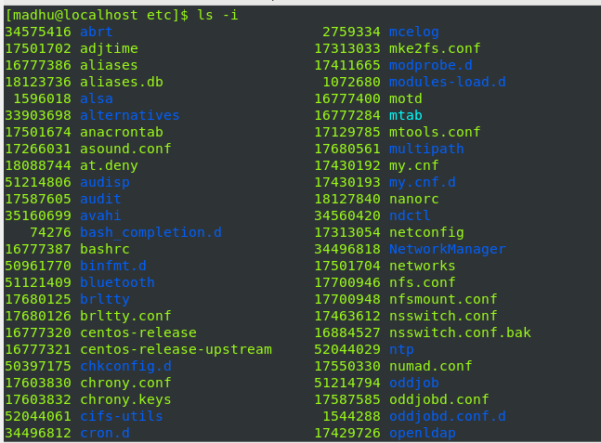

* Then use **ls –help** and see other options about **ls** command
  + Explore it and try with other attribute we can use with **ls** command

Answer: -

ls –help will show all the commands and their explanation in ls.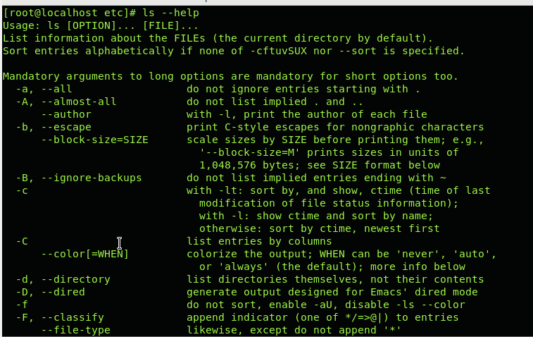

Assignment-5

Know where you are and where you are working

*Here we use* ***pwd, cd and ls*** *as combine task to understand where you are working on terminal and how you can switch from one directory to another one.*

* Open terminal after restart the linux
  + Check which location you are working, type **pwd** and take screenshot

Answer: -

Pwd command shows the present working directory.

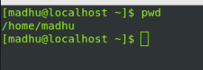

* Now use **cd /var** and hit **Enter** key
  + Do **ls,** and see what output comes, give screenshot?

Answer: - /var contains variable data files.

* Do explore other help options of each command to learn more other things we can do with these commands